FINAL INTERNSHIP PROJECT

Google Maps Lead Finding & Automated Outreach
n8n workflow documentation and completion report
Submitted to: Internship Mentor(SIr Mohsin), Logictrix Solutions
Project team: Saira Iftikhar • Ghazi Abbas • Shahzaib
Reporting date: 2 November 2026
Prepared from the exported n8n workflow, workflow screenshot, and sample leads spreadsheet. Individual responsibilities have not been assigned because they were not supplied.

1. Executive summary
This project automates lead discovery from Google Maps, stores structured business contact data in Google Sheets, and routes eligible records into email and WhatsApp outreach. The system begins with a user-entered location and business type, retrieves listings through a RapidAPI Google Maps scraper, processes the returned results, visits business websites to locate publicly displayed email addresses, updates the lead database, and uses contact-based filters to initiate personalized messages.
The supplied evidence shows that the end-to-end workflow has been built and individual nodes have been executed in the n8n editor. A seven-record spreadsheet provides tangible evidence of captured lead data. The exported workflow has active=false, so publication/production activation and reliable delivery at scale should be treated as next validation steps rather than confirmed achievements.

2. Project objectives and scope
- Accept a geographical location and business category as search inputs.
- Scrape Google Maps business listings and standardize business details.
- Extract an email address from a business website when a suitable address is present.
- Write the collected leads into Google Sheets while reducing duplicates using an address match.
- Send personalized outreach through Gmail and WhatsApp when the respective contact field is available.

3. Workflow overview
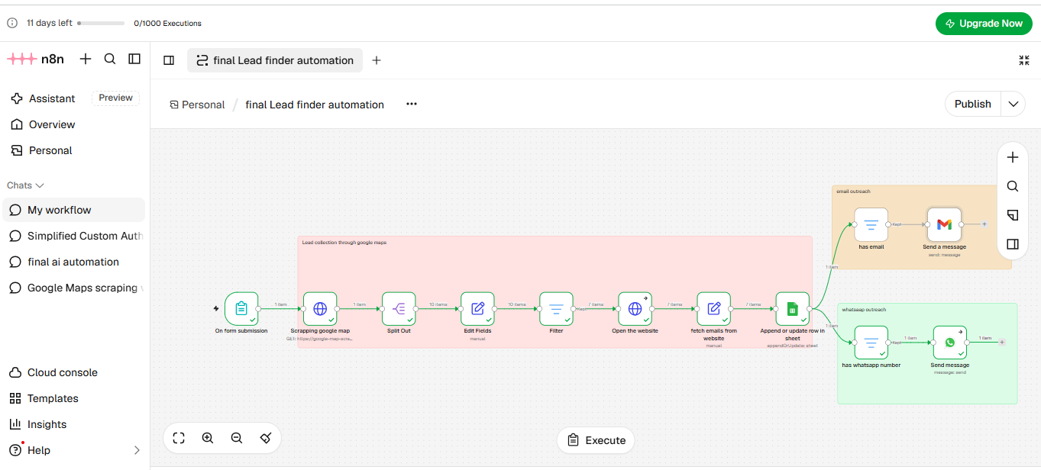
Figure 1. n8n workflow: lead collection (pink), email outreach (orange), and WhatsApp outreach (green).
Overall route: Form submission → Google Maps scraper HTTP request → Split Out → Edit Fields → Filter → Open the website → Fetch emails from website → Append or update row in sheet → [Email availability → Gmail] and [Phone availability → WhatsApp].

4. Detailed node-by-node explanation

01 | On form submission
Node type: n8n Form Trigger
Purpose: Starts the automation when the user submits a simple search form.
Configuration / processing: The form requests “Enter the location” and “Enter the business Type”. These two inputs become the search parameters for the next HTTP request.
Result: A structured input object containing the desired area and business category.

02 | Scrapping google map
Node type: HTTP Request via RapidAPI
Purpose: Retrieves Google Maps place-search results for the requested businesses.
Configuration / processing: A GET request calls the Google Map Scraper API place-search endpoint; the query expression joins the form’s location and business-type values. API authentication uses RapidAPI headers. Credentials are intentionally omitted from this report.
Result: An API response containing a data.results collection of business listings; availability and quality depend on the external API.

03 | Split Out
Node type: Split Out
Purpose: Turns a list of places into individual lead items.
Configuration / processing: Splits the data.results array so every business is processed separately by downstream nodes.
Result: One workflow item per business listing.

04 | Edit Fields
Node type: Edit Fields / Set
Purpose: Standardizes raw scraper results into a consistent lead record.
Configuration / processing: Maps the returned fields into place_id, name, address, phone, website, rating, reviews, and maps_url. This removes dependence on varying source-field names later in the workflow.
Result: A clean, structured business object ready for filtering.

05 | Filter
Node type: Filter
Purpose: Prevents businesses without a website from entering the website-email enrichment stage.
Configuration / processing: The condition requires the website field to be non-empty. Businesses lacking a website do not continue to Google Sheets or the outreach branches in this implementation.
Result: Only leads with a website are passed forward.

06 | Open the website
Node type: HTTP Request
Purpose: Downloads the publicly accessible business webpage for email identification.
Configuration / processing: Uses the website URL from the lead record and requests a text response; the node is configured to continue regular output on errors.
Result: Website response text (or an error-handling output) for the next extraction step.

07 | fetch emails from website
Node type: Edit Fields / Set
Purpose: Attempts to identify an email address on the retrieved webpage while preserving lead metadata.
Configuration / processing: Reads the website response text, applies an email-pattern regular expression, excludes matches resembling image filenames and several known irrelevant domains, and selects the first remaining match or an empty string. Reuses the original details from the Filter node.
Result: A lead record enriched with an email field when extraction succeeds. This is a best-effort match, not guaranteed verification of email ownership or deliverability.

08 | Append or update row in sheet
Node type: Google Sheets
Purpose: Persists the collected lead data in a central spreadsheet.
Configuration / processing: Runs append-or-update on the “leads information” workbook, Sheet1, using address as the matching column. It maps name_of_business, phone_number, address, email, website, URL, rating and reviews. An existing matching address can be updated instead of blindly appending another row.
Result: A saved or updated lead row, which is also supplied to both outreach branches.

09 | has email
Node type: Filter
Purpose: Restricts email outreach to records with a populated email field.
Configuration / processing: Checks that the Google Sheets output field named “email ” (including the trailing space in the column header) is non-empty.
Result: Email-eligible records only.

10 | Send a message
Node type: Gmail
Purpose: Creates and sends personalized prospecting emails.
Configuration / processing: Sends to the filtered email address. The subject is “Quick question for [business name]”. The HTML message references the business name and star rating and proposes a short conversation. The Gmail connection is configured in n8n.
Result: Gmail send operation is invoked for eligible records; a delivery or recipient-read confirmation was not provided.

11 | has whatsapp number
Node type: Filter
Purpose: Restricts WhatsApp outreach to records with a populated phone number.
Configuration / processing: Checks that the phone_number column is not empty. This checks presence only; it does not confirm WhatsApp registration, E.164 formatting, recipient consent, or template eligibility.
Result: Phone-eligible records only.

12 | Send message
Node type: WhatsApp
Purpose: Invokes WhatsApp messaging for eligible leads.
Configuration / processing: Uses the configured WhatsApp account and sender-phone ID. It passes the stored phone number as recipient and personalizes the message with the business name and rating; the node continues regular output on errors.
Result: WhatsApp send operation is invoked; successful delivery to all recipients is not established by the submitted artifacts.

5. Data captured and sample results
The supplied leads information.xlsx contains seven populated business records, with columns for business name, phone number, address, email, website, Maps URL, rating and review count. The visible sample relates to businesses in Lahore, Pakistan. The file also contains a blank second column after the business-name column, which does not change the main mappings.
Sample evidence | Observed result
Business records | 20
Records with a website | 15 of 20
Records with a phone number | 15 of 20
Records with an email | 7 of 20
Distinct non-empty addresses | 7
These counts describe the uploaded spreadsheet only, not the total number of businesses ever processed, messages delivered, or campaigns completed. Email availability in the sample is approximately 86% (6/7).

6. What has been completed
- Designed a connected n8n workflow with 12 operational nodes and 3 visual sticky-note sections.
- Created a reusable search intake form and configured API-based business discovery.
- Implemented normalization, website filtering, webpage retrieval and best-effort email extraction.
- Configured Google Sheets append/update storage and validated the presence of a populated leads sample.
- Configured separate Gmail and WhatsApp outreach paths with contact-field checks and personalized templates.
- Executed nodes in the n8n editor, as indicated by successful run markers in the submitted screenshot.

7. Current limitations and recommended improvements
- Production state: the JSON export has active=false. Confirm publication/activation and monitor complete production runs.
- Credential security: the exported JSON includes a RapidAPI key directly in the HTTP headers. Rotate that key and move it to n8n-managed credentials or secure environment variables before sharing or deployment.
- Lead coverage: the website filter excludes all businesses without a website, even if they have useful telephone numbers. Consider separately storing these leads.
- Email accuracy: regex extraction takes the first suitable match from a fetched webpage; validation, contact-page crawling, and business-email relevance checks would improve precision.
- WhatsApp compliance: a non-empty phone number is not evidence of WhatsApp availability or opt-in. Confirm applicable recipient consent, Meta/WhatsApp messaging requirements, and phone-number formatting.
- Campaign controls: add deduplication by place_id or a stable business identifier, outreach status columns, sending limits, error logs and retry rules to prevent unintended repeated messages.
- Verification: retain execution logs and provider message IDs/statuses to prove successful sends independently of the editor’s green execution marks.

8. Conclusion
The internship task has reached the functional workflow-build and sample-data stage: Google Maps lead sourcing, data cleaning, Google Sheets storage, and email/WhatsApp outreach pathways are integrated in n8n. The uploaded sample confirms that business leads were captured, while the workflow export documents the configured message-sending logic. Final production readiness should be confirmed through activation, end-to-end monitored testing, security cleanup, and channel-specific delivery verification.

Appendix | Evidence reviewed
- n8n workflow screenshot: final ai automation.png
- n8n export: final Lead finder automation.json
- Lead records: leads information.xlsx (7 data rows)
Note: No private API tokens, OAuth credential IDs, sender account identifiers, or personal lead contact information are reproduced in this report.

